Gospel Values  The Gospel Values are at the heart of all we do and inspire our work  Humility, seeing life as a gift  Compassion, empathy  Kindness, gentleness  Justice, working for a fairer world  Forgiveness, reconciliation  Integrity, do what you say  Peace, committed to peace making, non-violence  Courage, standing up for truth | RE  During RE for this term we will study at Creation; with a focus on what happened during creation and how this impacts on everything we do now. We will also think about how we are all part of God’s creation and what we can do to make sure this creation stays at its best. We will continue this term to look at Revelation and how God reveals himself in different ways. We will end the term looking at advent and the key themes for advent and how they are important as we prepare for Christmas. |  | Characteristics Of Effective Learning  At St Mary’s we want our children to be the best they can be, we encourage a love of learning through our Characteristics:  Go for it Gorilla: I will have a go  Editing Elephant: I can edit and improve my work  Creative Chameleon: I have my own ideas  Concentrating Crocodile: I join in and concentrate  Persevering Parrot: I keep trying  Proud Peacock: I am proud of what I do
Literacy  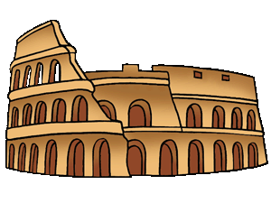  Over the course of the term we will study a selection of narrative and non-narrative writing. Within narrative we will study Roman myths – including the story of Romulus and Remus to explain how Rome was made. We will look at traditional tales and the features commonly associated with these types of story. Within non narrative we will study explanations texts and Newspaper reports. Finally we will look at a range of poetry and recreate poems in the style of acrostic poems. |  | Maths  During this term we will look at numbers and place value of numbers up to 1000. We will begin to understand how these numbers can be broken into hundreds, tens and units. We will begin looking at different ways to add and subtract using chunking on a number line. Next we will focus on a variety of strategies for multiplication and division. We will look at different types of measurement including length, weight, distance and mass. We will continue by studying time and start to understand past and to the hour. Within our study of time we will focus on Roman Numerals used for clocks such as Big Ben. Finally we will begin learning the 3 and 4 times tables during this term. In addition to this they will use reasoning to solve a variety of problems.
Science  We will look at animals including humans – we will know the importance of nutrition and where this comes from, we will look at food that will help to keep them healthy and the importance of balanced meals including all of the key types of food. Next we will study the functions of skeletons and muscles for animals and humans and will compare how these might differ. We will look at vertebrates and invertebrates and the names of bones in the human skeleton.  We will continue the term by looking at rocks. Over the course of the half term we will compare and group rocks based on their properties, we will describe how fossils are formed, and know that soils are made from rocks. | 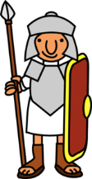  What did the Romans do for us?  Year 3 Autumn Term 2019 |  | PE  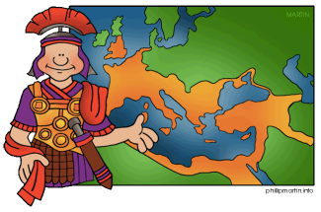  This term we will look at the key skills in involved in netball and rugby. We will learn to develop a range of passing and shooting skills in netball. In tag rugby, we will learn how to pass a rugby ball successfully using all team members to score a try.
Art + DT  Art: We will research how the Romans used mosaics to decorate floors following this research they will design and create their own mosaic, using a variety of tools. Next we will look at the artist Picasso and his range of portraits applying different techniques using oil pastels. We will use collage to create layers in a Roman inspired piece of art work.  DT: We will design and create a Roman Villa using a range of cutting, sticking and modelling techniques. We will use a range of tools in order to create their villa. | Humanities  History: We will work on what life was like during Roman times, the Colosseum in Rome, Pompeii and the eruption of Vesuvius. We will focus on the impact that the Romans had on our lives today.  Geography: We will study volcanoes and earthquakes with a specific focus on Vesuvius and the impact this had on the Romans. We will look at Europe – use various media to find and plot key countries and cities on a map. We will complete a project to understand a variety of similarities and differences of a region in Italy compared to where we live. |  | ICT  We will look at programs and how they work. As a result we will design, write and debug programs using a range of programs to understand how different programs work in different ways. We will work with various forms of input and output and understand how these can be used. We will look at using the internet and browser addresses.
PSHE  We will focus on health and wellbeing during this term. We will focus specifically on healthy lifestyles, and how to keep safe. We will continue to look at how the grow through their childhood.  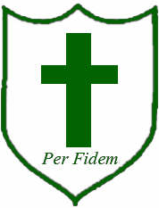 | Music  We will learn to understand and appreciate some different music from Roman times. We will continue through this term learning to compose their own piece of music to accompany a Roman film, they must reflect the mood changes in the different parts of the film and how to recreate these. |  | Forest School  We will be introduced to Forest School in Year 3 and will begin the term by learning to tie a variety of knots and learn about why this might be important. We will then use this skill to make a small scale Roman catapult. We will learn the importance of using fire in Roman times and will learn to light the fire. We will use the fire to cook on.
French
We will begin to join in with key words/phrases in French, for example hello, how are you? We will then explore what words mean for a range of family members, colours and animals.

