Year 4 taking part in Tag Rugby

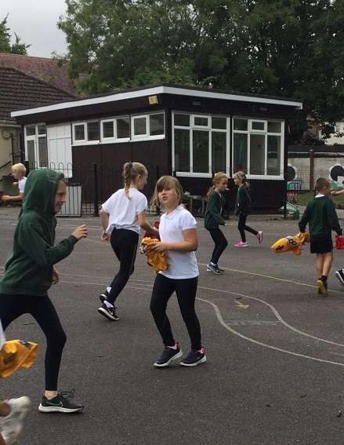

9th September 2022

Dear Parents
After the sad news yesterday that our Queen had died the children took part in a Liturgy to think about the Queen, celebrate her life and the many roles she has carried out over the years.
We reminded ourselves of the Queen’s Jubilee we were lucky enough to celebrate earlier this year.
The children also spent time watching the Queen have Tea with Paddington Bear, this video captures her personality beautifully as a wonderful lady with a huge sense of fun. The children were able to relate to this & enjoyed it.
Rest in Peace Our Queen

Welcome & Welcome Back
We were pleased this week to welcome our children back to St Mary’s. A very special welcome to our new Reception families. We are delighted to say the Reception class have had a super Friday, their first full day.
The other children have settled in very smoothly into their new classes and have already covered lots of areas of the curriculum this week.
Year 2 class have been learning about parts of the body in science, developing their ‘numbers’ in maths & each class has its own worry monster ready to take any worries that the children may have.

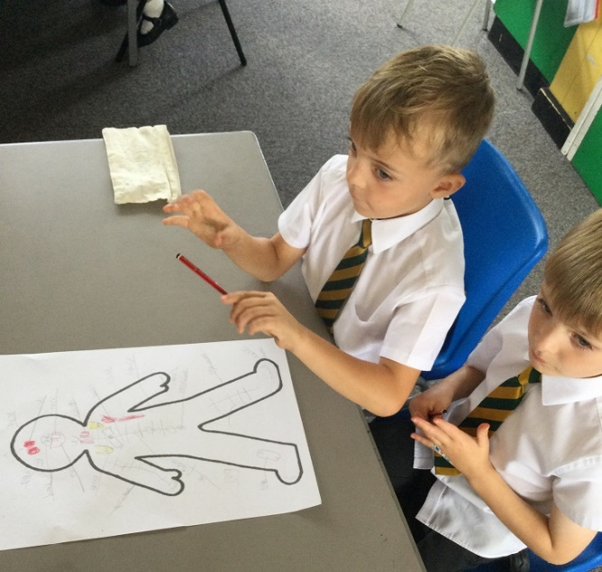

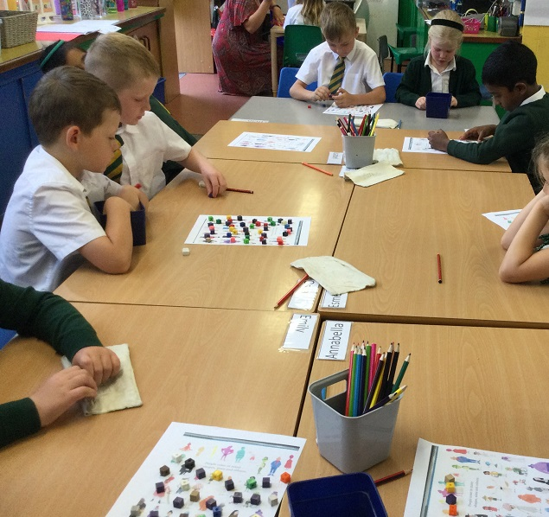

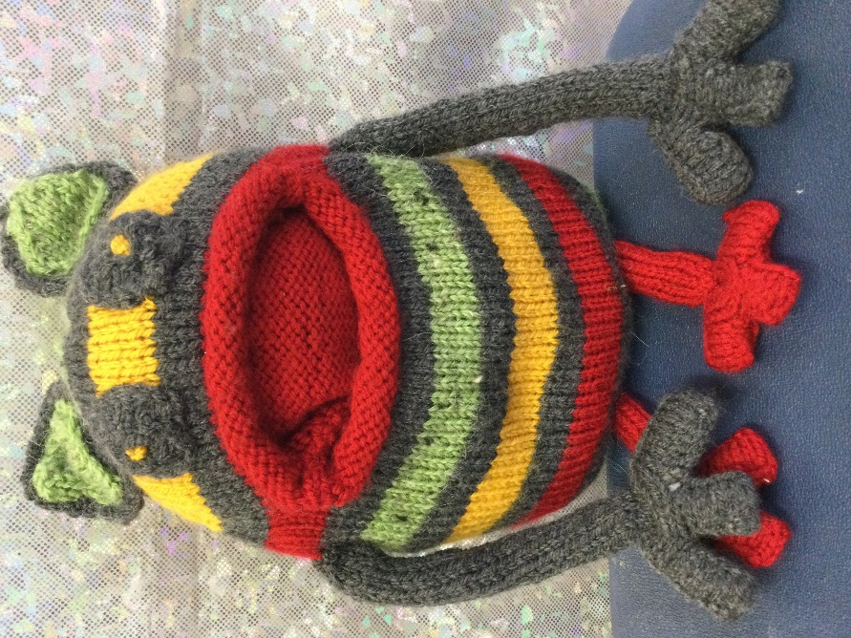

Our Mission Statement
Yesterday we had our Liturgy for Mary’s birthday, we celebrated her as a Mother and a role model for all members of our school family.
At the beginning of our new school year we revisited our Mission Statement.

Mission Statement
To be the best you can be, by following the Greatest Commandment by sharing God’s love with everyone we meet.

You shall love the Lord your God with all your heart, and with all your soul, and with all your mind. 'This is the greatest and first commandment. Love God above all else’.

The children & staff talked about living this greatest value each day of their lives.
The children were set a challenge to put this into words/pictures & they did not disappoint:

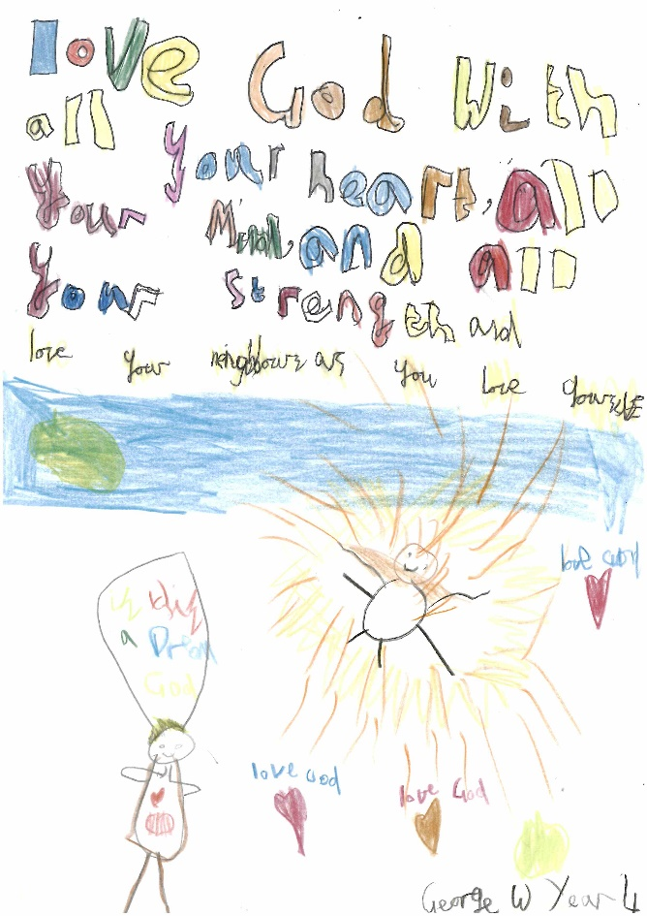

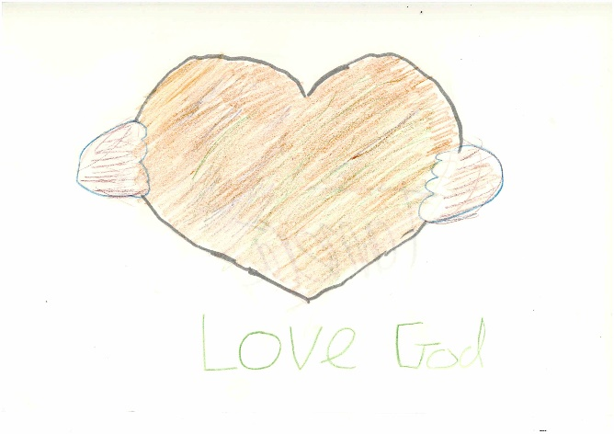

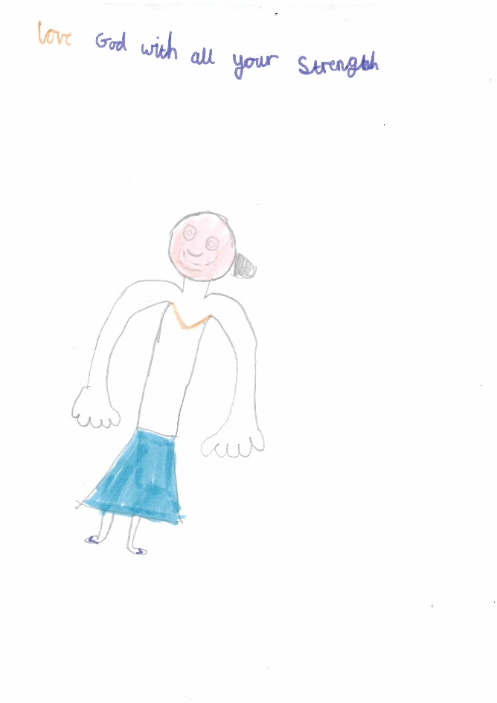

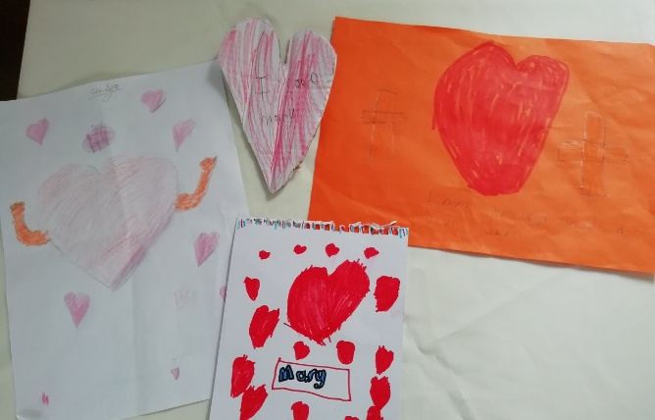

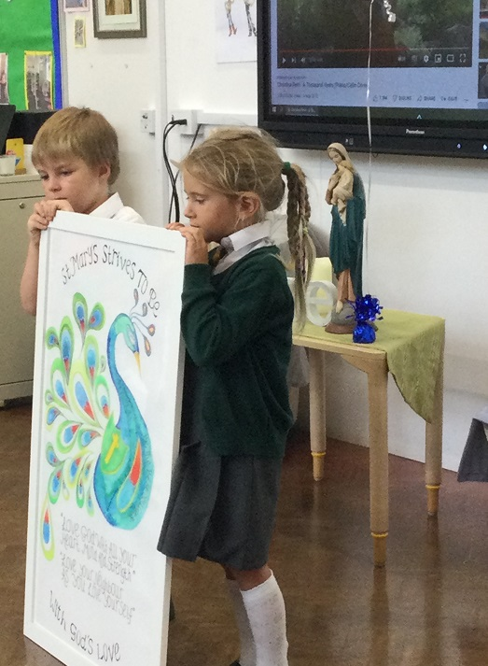

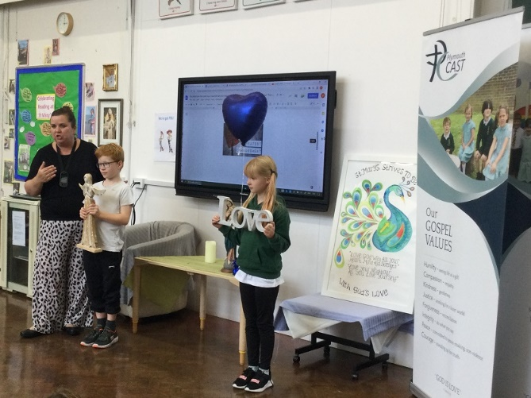

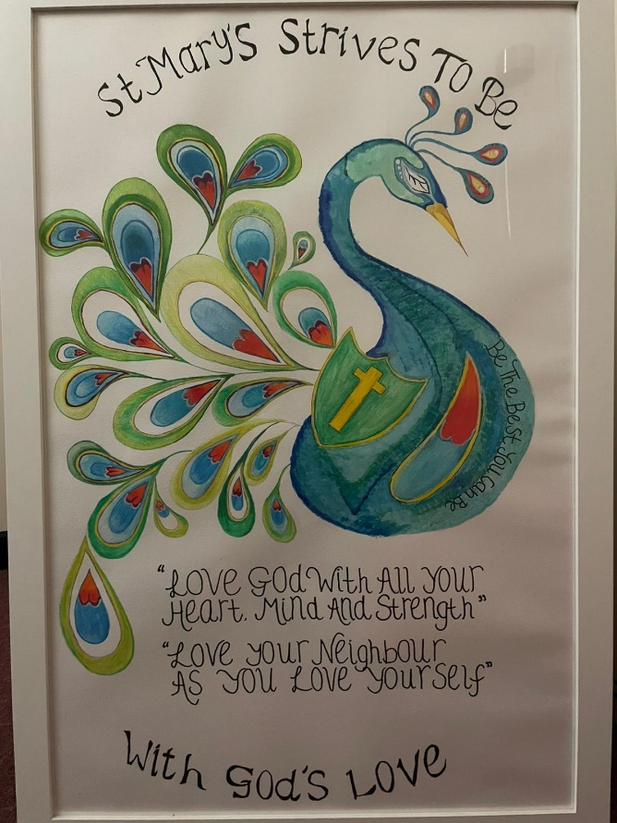

After School clubs
We have two sports after school clubs starting next week & we will announce the other clubs which will run later this half term next week.

School Pool
The school pool has now closed for the winter. Thank you to the Lifeguards, it is such a fantastic facility to have for our children. We are glad that the school children, Lifeguards & families were able to enjoy it.

A big thank you to the swimming pool committee who worked throughout the summer to ensure that our pool was available for our children, all your hard work is much appreciated.

Have a good weekend
P.Fearn
Paula Fearn
Headteacher

