Gospel Values  The Gospel Values are at the heart of all we do and inspire our work  Humility, seeing life as a gift  Compassion, empathy  Kindness, gentleness  Justice, working for a fairer world  Forgiveness, reconciliation  Integrity, do what you say  Peace, committed to peace making, non-violence  Courage, standing up for truth | RE  In the first half term we will be further exploring the creation story; linking this to our responsibilities in terms of appreciating and looking after our natural world in Forest school sessions. We will learn more about prayer life, feasts and Saints alongside an understanding of the Islamic faith.  After half term we will be preparing for Advent; discovering more about Sacraments. This will lead into our Christmas topic, linking with the understanding of community and others. |  | Characteristics Of Effective Learning  At St Mary’s we want our children to be the best they can be, we encourage a love of learning through our Characteristics:  Go for it Gorilla: I will have a go  Editing Elephant: I can edit and improve my work  Creative Chameleon: I have my own ideas  Concentrating Crocodile: I join in and concentrate  Persevering Parrot: I keep trying  Proud Peacock: I am proud of what I do
Literacy  A trip to Lulworth castle will prompt both fiction and non- fiction writing in the first half term. The children will learn how to record real life events clearly whilst also receiving a rich setting stimulus for their story writing.  After half term the children will learn about the gunpowder plot, using this information to write a simple poem. This will link to their understanding of our history and help with recount writing. During Advent your child will be invited to “Books At Bedtime “. This will prompt the writing of a Christmas story, letter and lists!  Your child will have weekly guided reading sessions linked to the writing they are doing that week, including play reading in the build up to our school performance before the Christmas holidays. |  | Maths  In Autumn 1 we will be looking at place value and the four operations of adding, subtracting, dividing and multiplying numbers. Some of the work will be linked to our Forest School sessions, our topic on castles and everyday school events. During our handling data week we will link our learning to our Science topic on materials looking at problem solving and reasoning.  In Autumn 2 we will be focusing on measuring, sequencing, money and shape. These will also be linked to our other curriculum areas wherever suitable so that children begin to see the links and the purpose behind the tasks.
Science  Our Science topic in the first half term is materials- which will also be explored through DT and maths. The children will design a test, undergo the test and then review their learning.  In the second half term we will be focusing on keeping ourselves healthy both physically and mentally. Talks from a nurse and a dentist will help the children understand about fitness, hygiene and survival. PE lessons will also help the children see the link between physical and mental wellbeing. | What Is It Like Living In A Castle?  Year 2 Autumn Term 2019  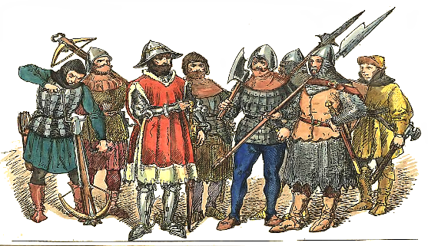 |  | PE  To complement our castle topic the first half term will be based around fencing and defending. Our specialist sports teacher will focus also on the enjoyment of sport and the importance of the “Go for it Gorilla” characteristic.  After half term the children will have gymnastic lessons where they will learn more about the fitness of their bodies, their strengths and the importance of exercise.
Art + DT  In DT the children will be designing, making and reviewing a model castle that can stand up. This will link with the Science study on materials.  In art, linking with the learning of sequencing in maths and the Advent/Christmas theme in RE the children will be designing patterns for wrapping paper. As an Eco friendly school we will also be discussing further uses for wrapping paper after presents have been opened on Christmas morning. | Geography  We will be exploring areas of the UK through our castle topic using an atlas and different maps. We will be questioning why castles are built where they are and debating on our favourite castles!  In the second half term we will be learning about continents and hot/cold places. This will be linked to our favourite Christmas visitor and the journey he takes to reach us. We will use this as a stimulus to discuss landmarks and use of land. |  | ICT  This year the children will be following the Purple Mash ICT scheme. The skills that they will learn through this will link with the Nation Curriculum standards for year 2.
PSHE  In the first half term the children will be learning how to build stronger relationships with one another and further their ability to negotiate, be assertive and work together in a constructive manner.  In the second half term they will be learning how to problem solve.  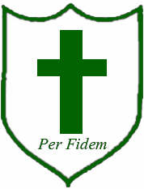 | History  A visit to Lulworth castle will prompt discussions on past and present wars, courage, justice and peace making. It will link to PSHE on the ability to negotiate and build relationships. This will lead to a recount of the trip, embedding their learning. Children will take part in a remembrance service; adding to their understanding of past and present wars. Learning about the gunpowder plot will enhance their understanding of British history and significant people. It will encourage questioning and debate. |  | Forest School  Linked to our PHSE lessons the children will be focusing on team building. They will be exploring natural materials which will in turn link to the Science topic.  Small character clay creations and choice of settings for them will aid story telling as well as experiencing, first hand, the physical and mental benefits of being outside.

