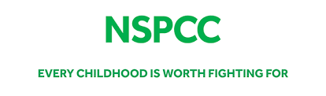

This term our classes have been discussing the NSPCC’s Underwear Rule in our PSHE lessons.



During these discussions we will aim to teach our pupils the following important safety skills without giving explicit information or telling scary stories. We will be teaching our pupils the NSPCC’s Underwear Rule, using the ‘PANTS’ acrostic, which is like a green cross code for staying safe from sexual abuse. PANTS stands for:

• Privates are private
• Always remember your body belongs to you
• No means no
• Talk about secrets that upset you
• Speak up, someone can help

The lessons will introduce a range of ideas, all delivered in a way that’s fully age appropriate. These include:

• “appropriate” and “inappropriate” touching
• your child’s right to say no to things that make them feel upset or
uncomfortable
• naming parts of the body
• who your child can turn to if they ever feel upset or worried.

If you would like to know more about the NSPCC’s campaign and see how you can help keep your children safe in partnership with your child’s school, more information can be found at nspcc.org.uk/underwearrule

If you have any questions or concerns please don’t hesitate to get in touch.

