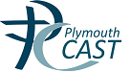
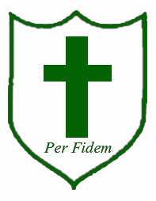 Key Stage 1 Assessment 2017

St Mary’s Catholic First School

 | School | National
Year 1 Phonics results | 83% | 81%

 | Expected | Level | Greater Depth | Level
 | School | National | School | National
Reading | 90% | 74% | 30% | 24%
Writing | 83% | 65% | 10% | 13%
Maths | 90% | 73% | 20% | 18%

