[](http://www.google.co.uk/url?sa=i&rct=j&q=&esrc=s&source=images&cd=&cad=rja&uact=8&ved=0ahUKEwjfn8vSz73JAhUF2BoKHe-jBqQQjRwIBw&url=http://www.clipartbest.com/african-clip-art&bvm=bv.108538919,d.d2s&psig=AFQjCNFS316UIwpTckOshmefXjJVdxtmTQ&ust=1449161019057588)[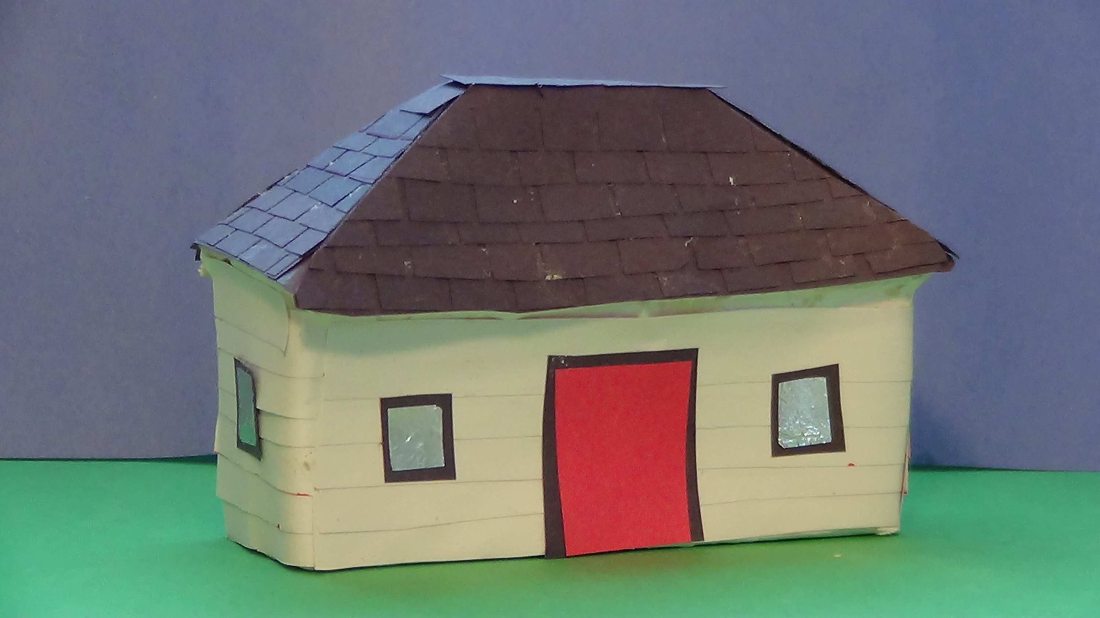](https://www.google.co.uk/url?sa=i&rct=j&q=&esrc=s&source=images&cd=&cad=rja&uact=8&ved=&url=https://www.youtube.com/watch?v=Tfb5ZLFqJ-w&bvm=bv.108538919,d.d2s&psig=AFQjCNEW_N7m7MEVwIshEer2rHdSEa6FZQ&ust=1449161090532256)[](http://www.google.co.uk/url?sa=i&rct=j&q=&esrc=s&source=images&cd=&cad=rja&uact=8&ved=0ahUKEwja6fakz73JAhVDvBoKHb3eDpcQjRwIBw&url=http://www.clipartpanda.com/categories/world-clip-art&bvm=bv.108538919,d.d2s&psig=AFQjCNFCnqF4ZBiaROOiByoX6_nhQRq9_Q&ust=1449160926490258)

**R.E.**

* Epiphany
* Revelation
* Parables
* Other Faiths
* Lent
* Holy Week

**Science**

* Animals and their habitats
* Seasonal changes for winter and spring

# PSCHE Good To Be Me & Going for Goals

# To recognise, name and deal with their feelings in a positive way.

# To think about themselves, learn from their experiences and recognise what they are good at.

# How to set a simple goal.

**I.C.T.**

* Using the Internet
* Saving and creating using different programs.

**Art/DT**

* Look at and recreate

different pieces of art from other countries.

* Food technology – hygiene and preparation of food.

**Music**

* Use voices in different ways.
* Play tuned and un-tuned instruments.

**History**

* Look at a key individual from our area (Thomas Hardy)

**Geography**

* Compare and contrast an area of the UK (London) with our area and other countries around the world.

**Around the World**

**Year 1-Spring Term 2018**

**Literacy**

* Stories from different cultures
* Instructions
* Poetry

**Numeracy**

* Number
* Shape
* Measuring