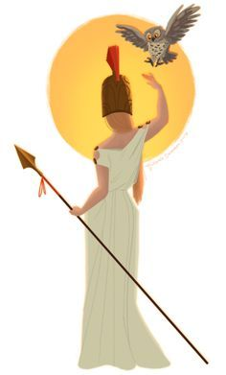

Maths

* Area and Perimeter
* Geometry - angles, triangles, quadrilaterals
* Symmetry of shape
* Position and movement
* Mass, Volume and Length

RE

* Easter - exploring the Resurrection
* The Road to Emmaus
* The Ascension and what it meant to the Disciples
* The promise of the Holy Spirit
* Exploring other religions

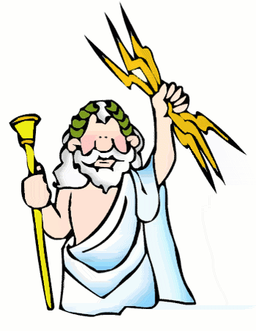

Art

* Medusa masks
* colour mixing
* line drawing

Science

* Habitats
* Rocks and Soils

History

* Chronological ordering of events in Ancient Greece
* Ancient Greek Gods and Goddesses
* The difference between Sparta and Athens
* Daily life in Ancient Greece
* Greek Myths

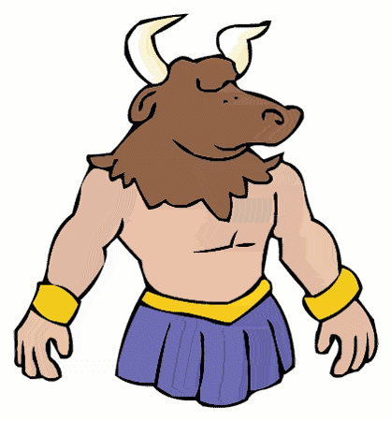

Heroes and Mythical Beasts

PE

* Led by Mr Kent including athletics, summer games and swimming

Literacy

* The 12 Labours of Heracles
* Sorting out the Heroes and mythical beasts from a range of Greek Myths
* Retelling and planning a Myth.
* Writing a playscript for a Greek Myth
* Freeze frames and drama work
* Persuasive letter writing
* Instructions on looking after your own Mythical Beast

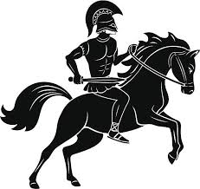

PSHE

* SEAL programme of study

Geography

* Design a travel brochure to persuade people to holiday in Greece
* Design a programme for the Olympic Games
* Look at life in modern day Greece

French

* Songs and rhymes visiting French places through paintings.
* Basic conversation skills