**Numeracy**

* Number & Place Value
* Calculating
* Measurement
* Multiplication tables
* Handling Data
* Understanding shape
* Using and applying

**R.E.**

* Epiphany
* Revelation
* Lent
* Holy Week

**Science**

* Light and dark; recognise the need for light to see things, know that light is reflected from surfaces, know how shadows are formed.
* Forces and magnets; compare how things move on different surfaces, think about magnetism and group objects based on this.

**French**

* Name parts of the body.
* Respond to simple instructions.
* Name items of clothing.

**Art/DT**

* Use a pencil/paint with control.
* Create a cloth by using weaving in the style of the Anglo-Saxons.
* Explore Native American designs and use these to decorate a clay pot.

**Literacy**

* Non-Chronological Reports
* Instructions
* Adventure and Mystery stories; Beowulf
* Poetry and Calligrams

**PSHCE**

* Say No to Bullying
* Going for Goals

**Anglo-Saxons**

**Year 3- Spring Term 2018**

**I.C.T.**

* Use a drawing program to draw lines, objects and manipulate these.
* Understand the internet and how it can provide multiple services.
* Use search technologies effectively.

**Geography**

* Explore the USA and think about how it is made up of different states.
* Think about the habitats that the USA has and the range of animals that live there.

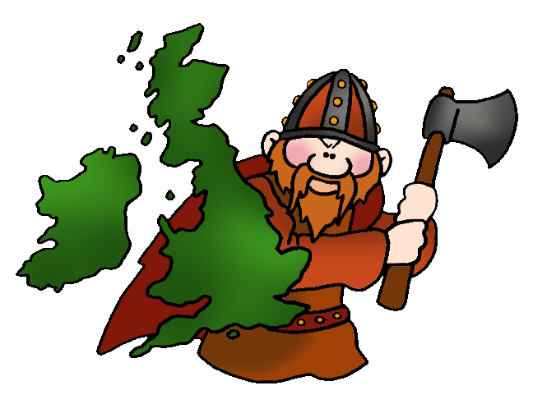

**Music**

* Explore the musical elements; pitch, durations, dynamics, tempo, timbre, texture and silence.
* Use an instrument with control and rhythmic accuracy.

**History**

* Investigate what it was like after the Romans left.
* Think about why the Anglo-Saxons left their homes in northern Europe.